

Tom Roberts Adventure Centre

Yates Farm, Malswick, Newent Gloucestershire, GL18 1HE

www.tracnewent.org.uk

**How To Find Us**

**Using SATNAV? – Type in ‘Tom Roberts Adventure Centre’ and NOT the Postcode as this takes you to the Malswick House pub down the road**

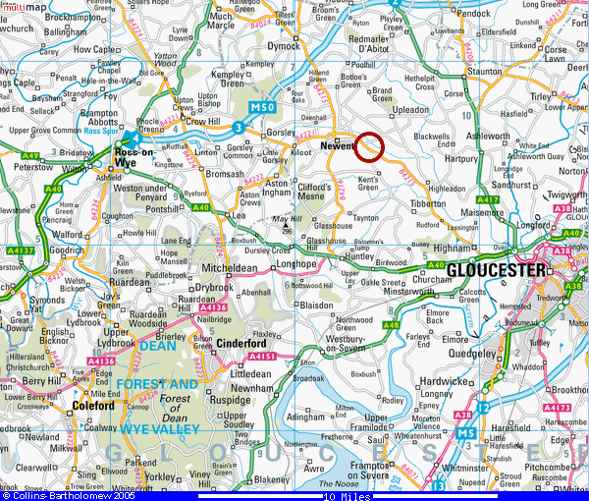

**Directions**

**From A40 Gloucester**

Take B4125 turning off A40 at Highnam signposted to Newent and after approximately 6 miles you will pass the turning (on your left) to Kent’s Green. Continue on the road to Newent for 160 metres and you will see the TRAC sign and Flag at the entrance to TRAC, which is through a pair of black wrought-iron gates on your left–hand side. If you reach ‘All about Dogs’ and then later the Malswick House Pub and Newent AFC on your right-hand side, you have gone too far.

**From Newent towards Gloucester**

Approximately one mile from the main crossroads of the B4215/B4221/B4216 on the Gloucester-Newent road, you will pass Newent Town AFC and the Malswick House pub on your left hand side. ½ a Km later you will pass ‘All About Dogs’ on the right and the entrance to the canal car park on the left. 160m past this you will see the TRAC sign and Flag at the entrance to TRAC, which is through a pair of black wrought-iron gates on your right–hand side. If you reach the turning to Kent’s Green on your right-hand side, you have gone too far.